COMMITTEE AND MANAGER INFORMATION
MARCH 2019

ANNUAL GENERAL MEETING
This will be March 9. Proxy forms are in the office if you can not go to the meeting. There will be elections for the committee and Juristic Manager

CEILINGS
We have made new ceilings on floors 11, 12, 13, 14 and 15. We plan to do floors 7, 8, 9 and 10 later. The ceilings and new lighting cost 140,000 baht per floor. We had some unused money from the building repair budget.
Many people said the ceilings and LED lighting look very good and all the wiring is now hidden. We hope all floors will have new ceilings by next year. We also plan to check all the wiring in the ceilings and around the building
We have repaired and painted the corridors on these floors

ROOF REPAIR
We repaired 20% last year. We planned to do more of the roof in January but there was a delay getting the guarantee and work specification. It rained in early February and we decided to wait until the dry months again. We budget to repair the rest of the roof over 2 years. Cost 400,000 baht this year

SWIMMING POOL
We plan to repair the pool in March or April. Cost about 200,000 baht. Time about 3 weeks. We will decorate the wall where the bridge used to be.

FIRE SYSTEM UPGRADE
We will replace old heat detectors and add smoke alarms per floor with new wiring. We will add 2 more fire bells per floor. We have repaired the diesel fire pump. Cost 170,000 including upgrading the old emergency lighting system.
We are upgrading all the emergency lighting system
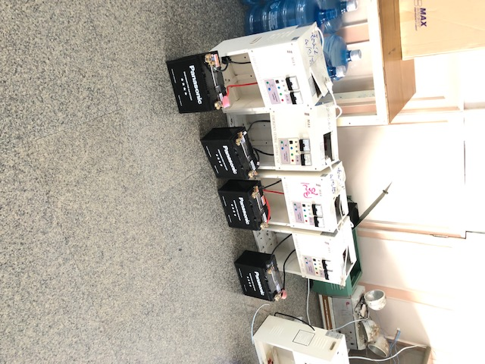

ELECTRICAL SYSTEM
We have done maintenance on the transformers and main breakers. Cost 100,000 baht. Owners ask why we do electrical work in high season. Because the maintenance schedule is in December/January. If we do not complete it on time, the transformer insurance is not valid.

FINANCES
Our budget and real expenses were about the same again this year. We were lucky not to have many unexpected expenses in 2018

INTERNAL PHONE SYSTEM
Repairs 30,000 baht

CAR PARKING
We will delete the old cards and issue new ones after checking documents. We have some problems because some people are using cards that are not theirs.

SELLERS' INFORMATION
The condo requires the common fee to be paid in full for the year before issuing the debt-free certificate. It is up to you if you want a refund from the buyer.

If you paid a deposit to pay for utilities and some of this is not used, you will get a refund.

PEST CONTROL
We have a yearly contract - cost 75,000

TOT FIBRE OPTIC
TOT have installed terminals on all the floors. They will run lines to all their customers' rooms and automatically upgrade their customers to fibre. Speed are 50 to 200 Mbps. Owners who want to change to TOT can talk to the manager.

DIGITAL TV SETTINGS
You should have 140 channels. If not, you may need to change a setting. The technician can help you do this for free

LIFTS
We have replaced all the door rollers. Cost 144,000 baht. They have been causing lifts to stop.
We have installed UPS systems in the lifts so that if there is a power loss, the fan and light still work

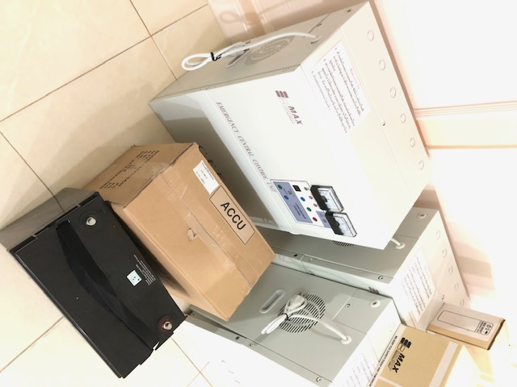

SMOKE IN CORRIDORS
There have been complaints about the smell of smoking in the corridors. If you smoke, you should close the inner door. The corridors are well ventilated and the smell of the smoke is carried into other rooms disturbing other residents.

