COMMITTEE AND MANAGER REPORT
OCTOBER 2021

1. Fire system upgrade

We have replaced the whole emergency light system. The new system has an auto-start generator connected to large 50 watt LED lights in the corridor. All the wiring is new.

The fire pump has been serviced and improved. It gives high pressure even on the 16th floor.

We have added a fire point on floor 9.

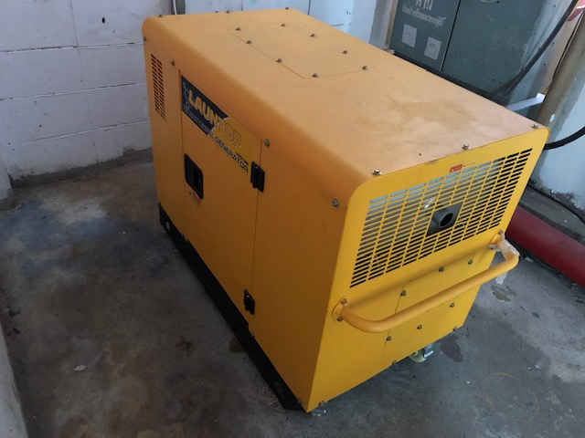 | 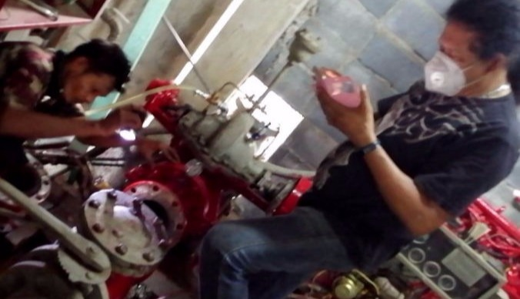

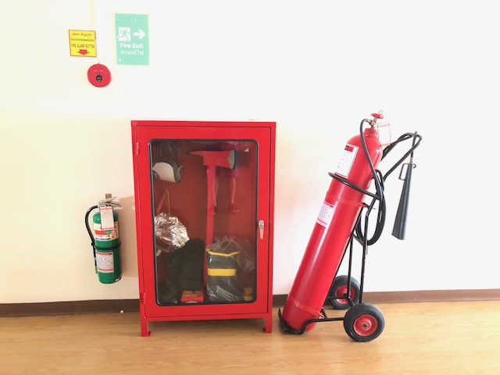 | 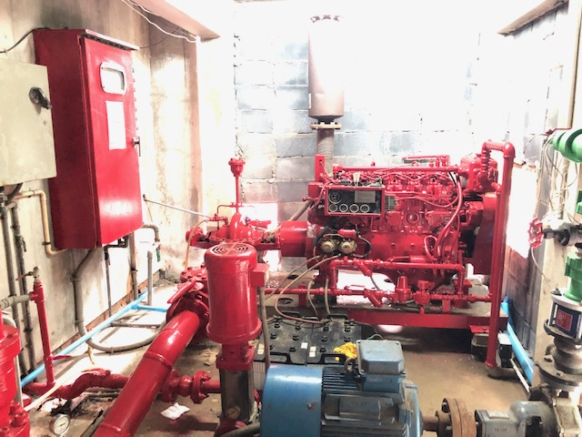

2. Floor waxing.

The cleaning team waxed all the floors a few months ago. The inside of the building is looking very clean and nice.

3. Salt-water pool

The system is complete and working well. For the first time, we have a full circulating system.

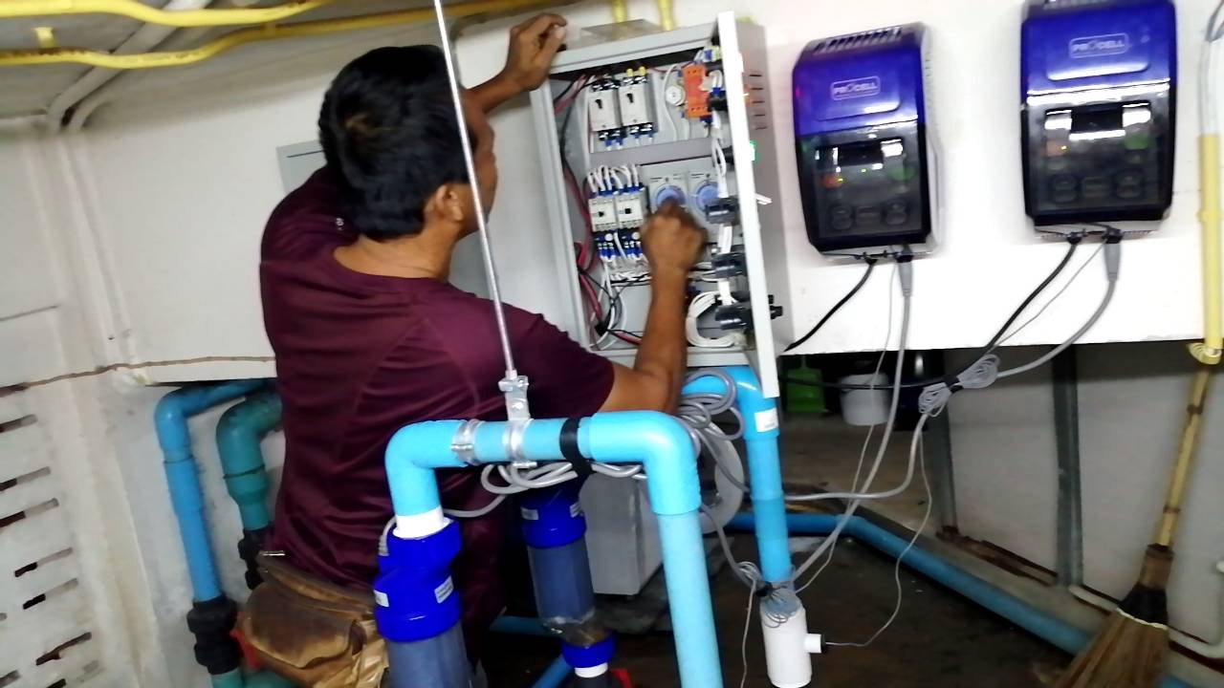 | 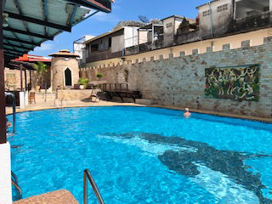

4. Gym

A new mutli-gym has been added. Broken cables have been replaced.

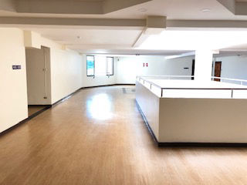 | 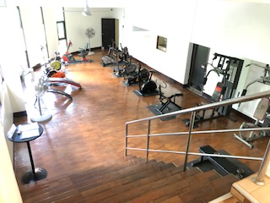

5. Bicycle parking

We will create more space to park bicycles

6. Pest controL

A company has sprayed the building to control pests

7 New website

We have a new website at http://www.centercondopattaya.com

We plan to translate to Thai.

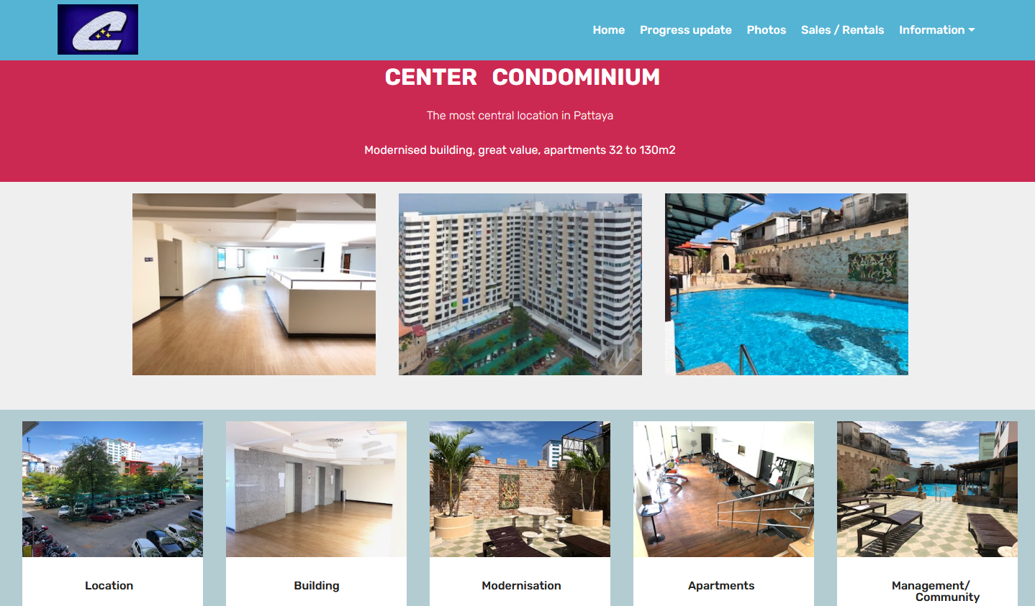

8. Emergency lights

We are installing more emergency lights and fire escape panels in the lift area.

9. Electrical system

The manager organised to remove or re-route much of the old telephone wiring. This includes a mass of wires near the transformer.

Now it is much safer and easier to service.

BEFORE AFTER

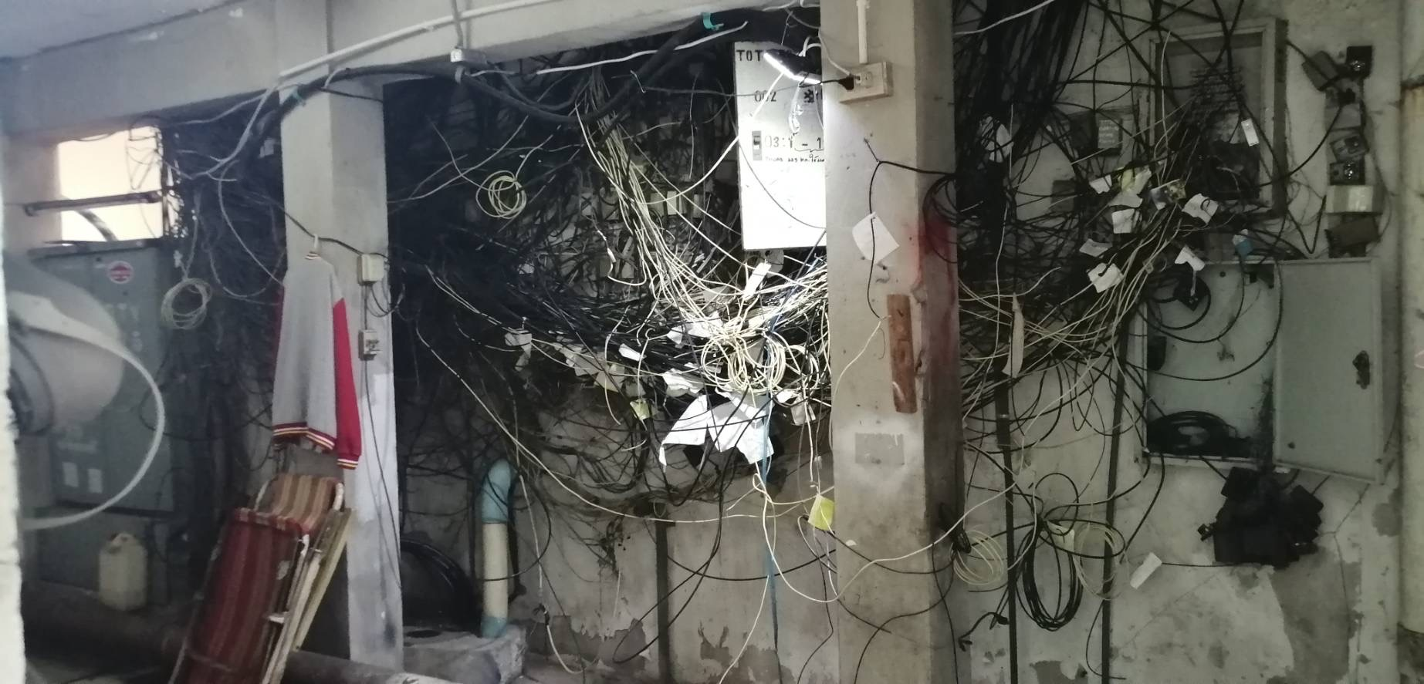 | 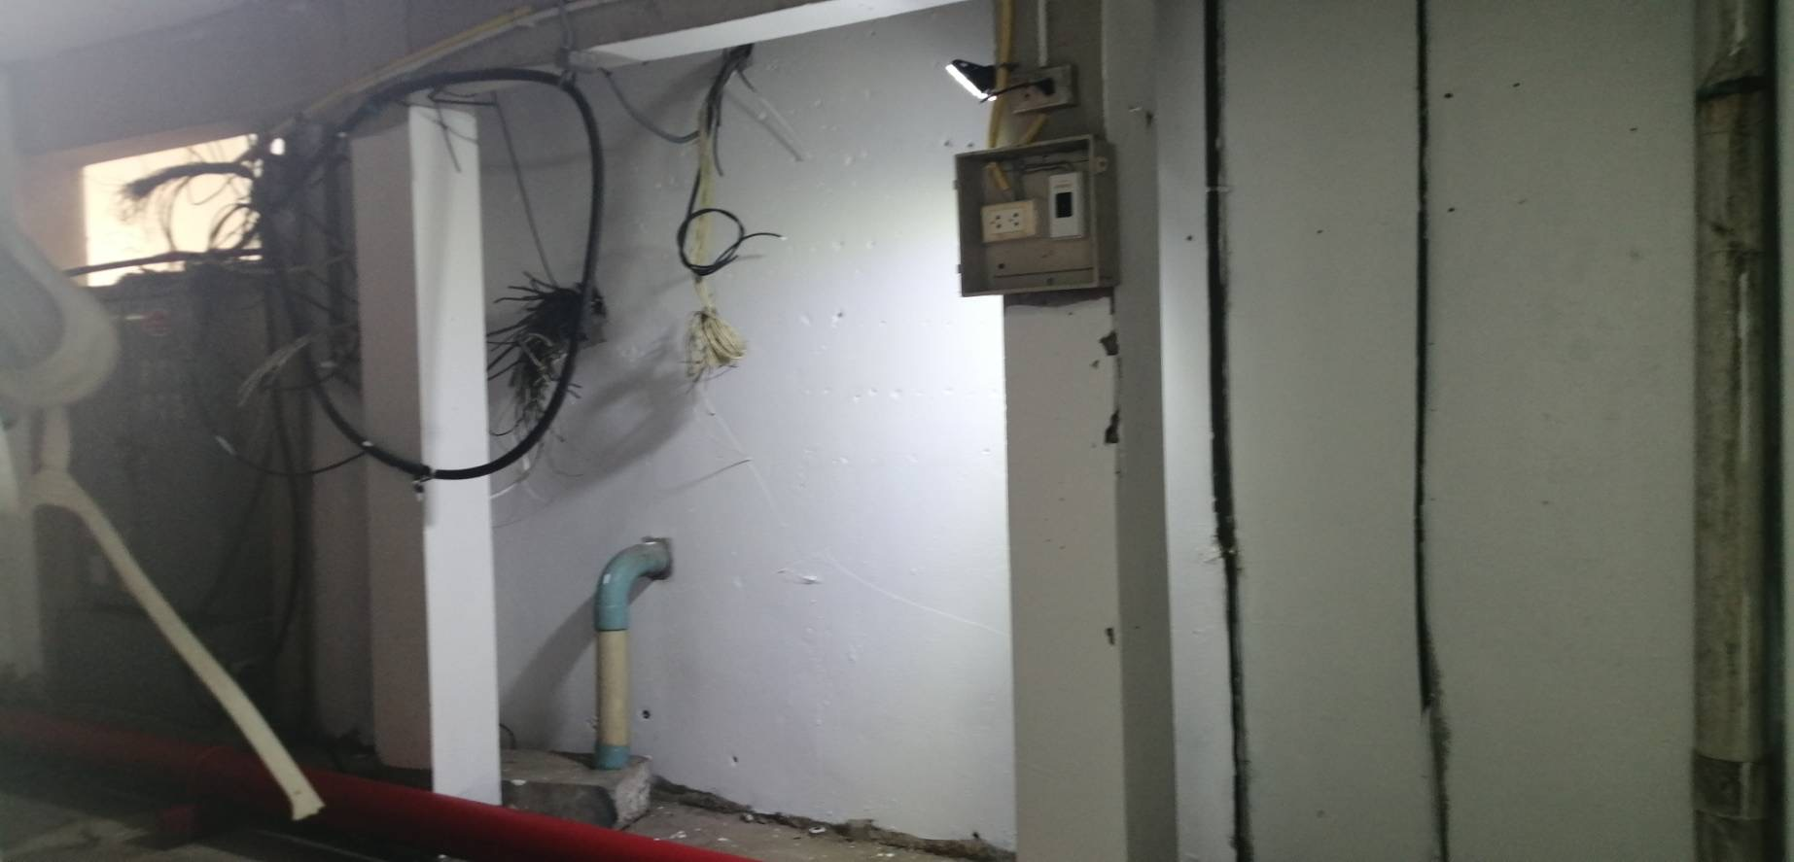
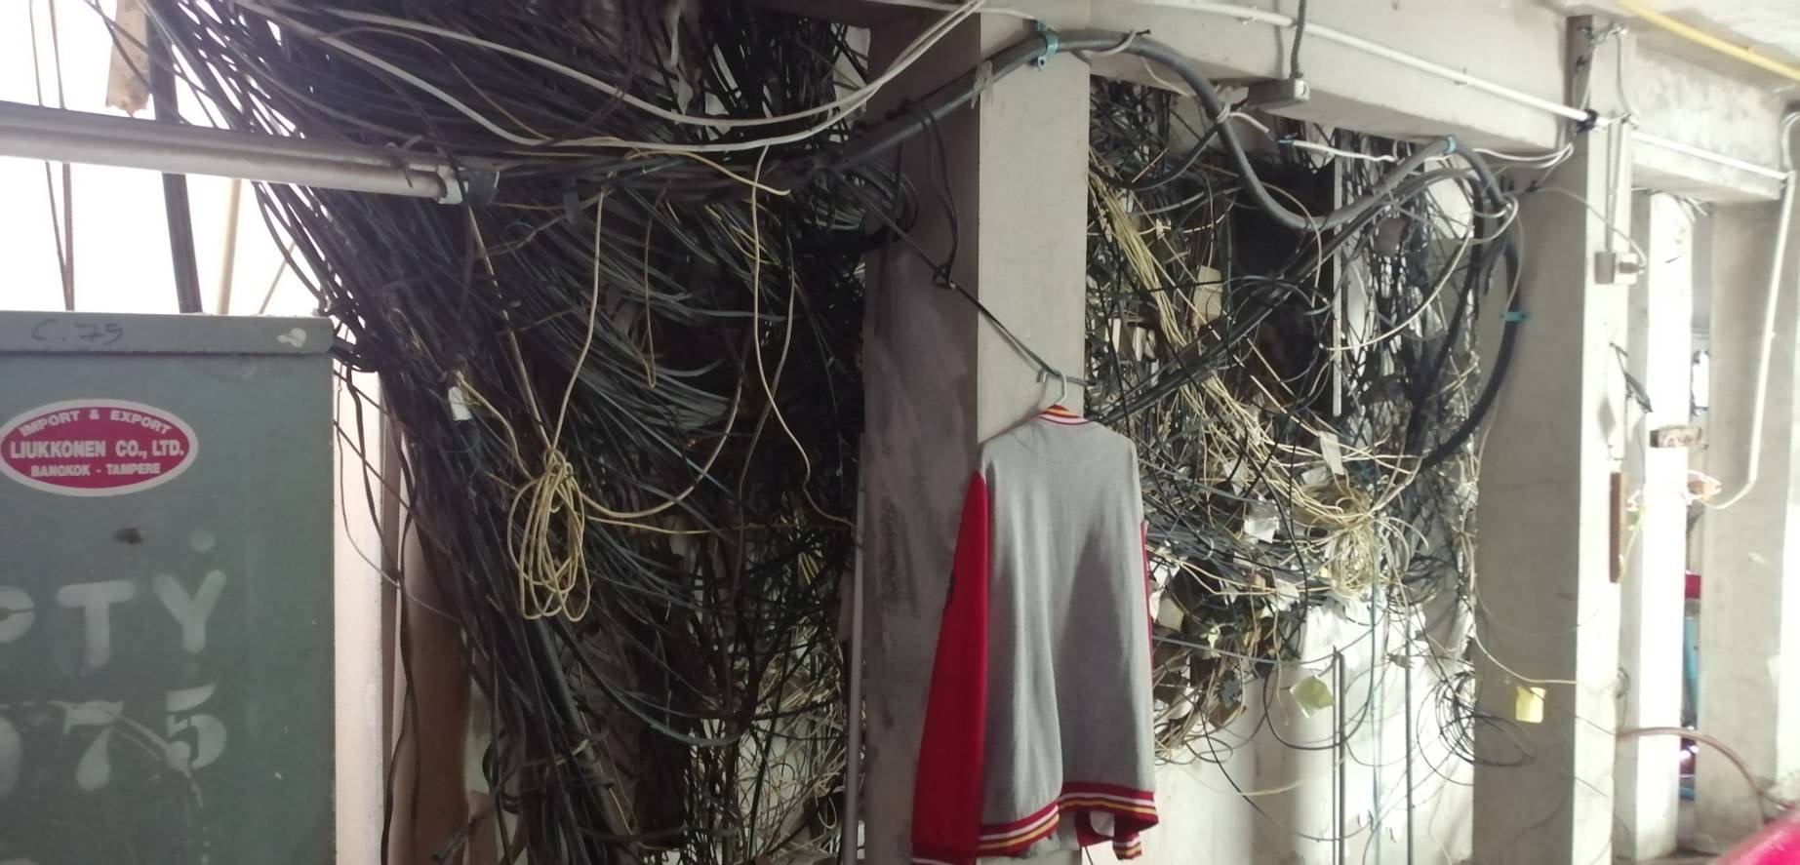 | 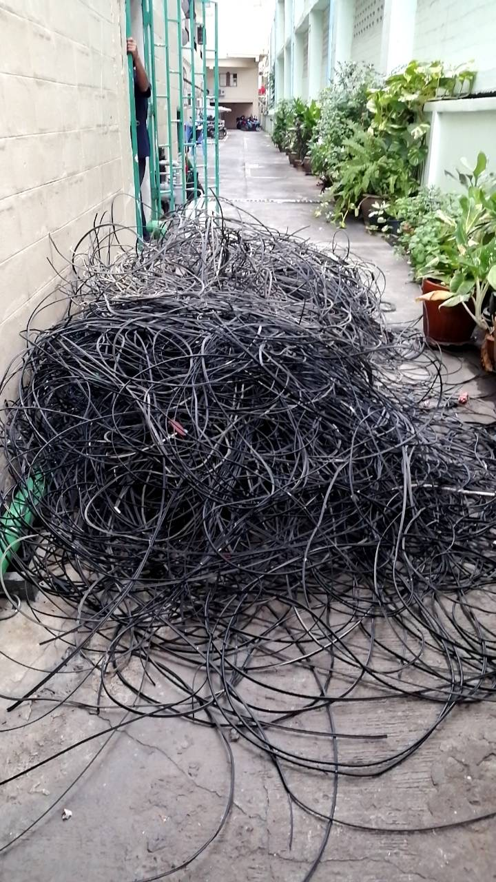
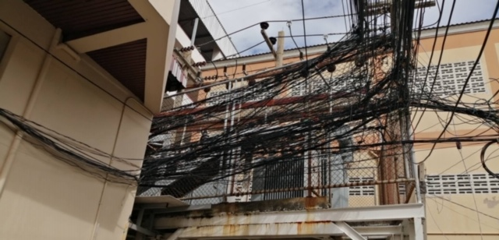 | 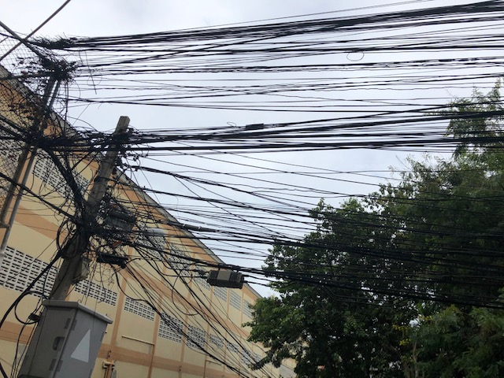

10. Pattaya Tai Entrance

Part of the walkway we have been using does not belong to us after checking the Title Deeds.

We own only 130 cm on the Family Mart side. We had to move the main water pipe to our side. We moved the original key card entrance from the street to the car park side.

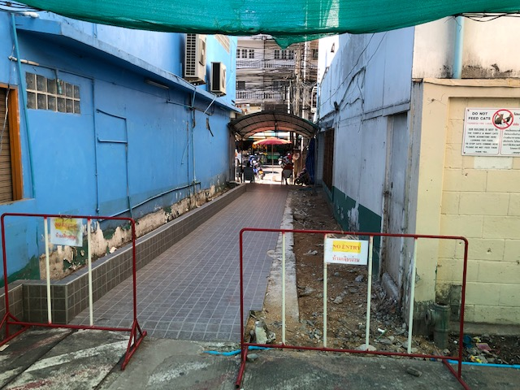 | 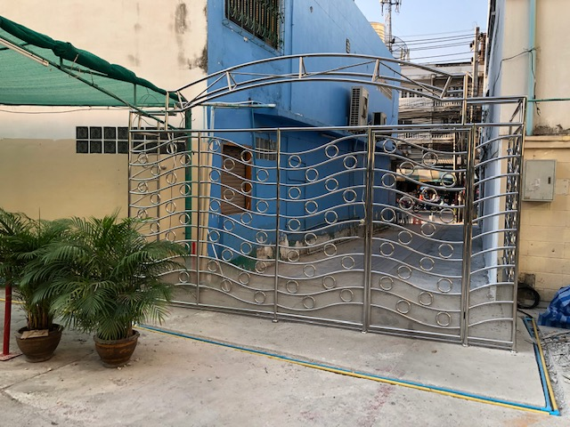

11. Roof

We painted the whole roof and repaired small cracks with 3 coats of TOA Roofseal products. We have painted white to reduce the heat into apartments on the 15th floor.

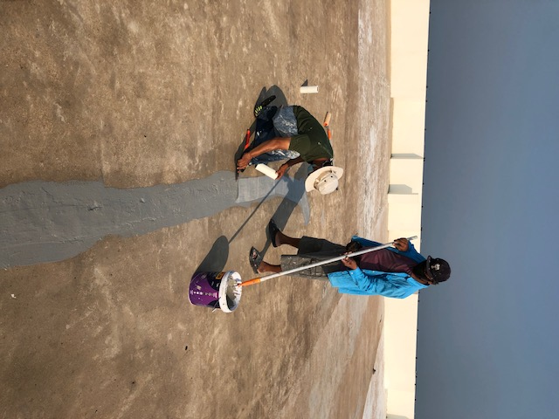 | 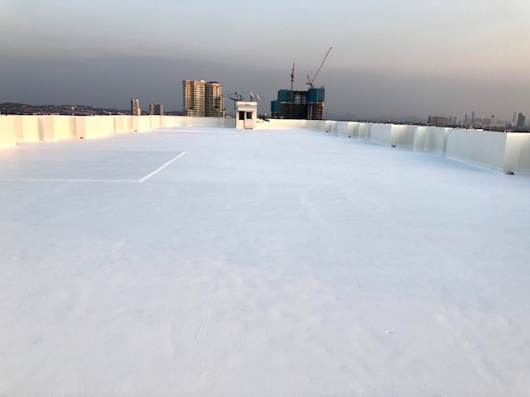

BEFORE AFTER

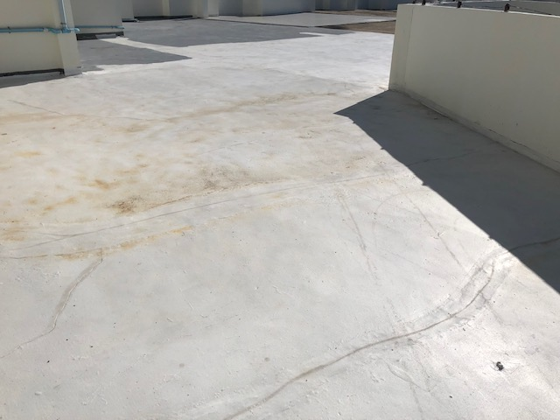 | 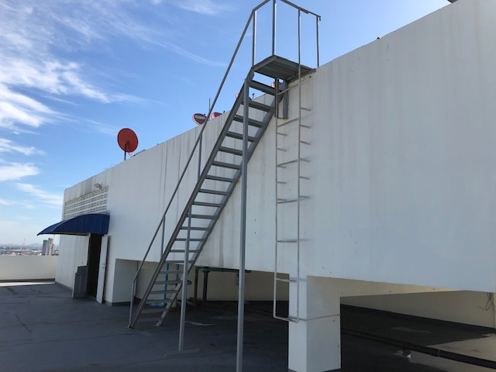

12. Roof staircase

Chief technician Boompeng built the roof staircase. It is much safer and easier to get to the lift motor room.

13. Lift motor room

The air conditioners and fire equipment were upgraded. Old satellite antennas were removed.

14. Internet cables.

All the TOT and 3BB cables are being replaced after wind damage.

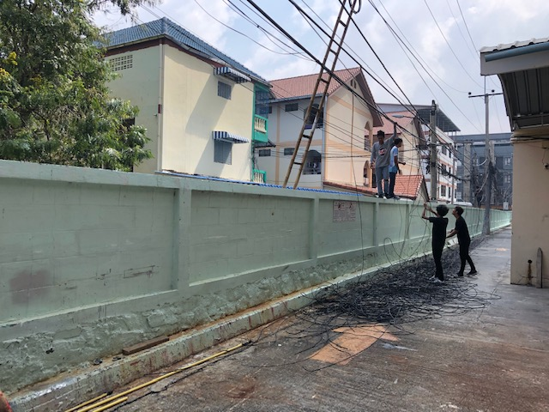 | 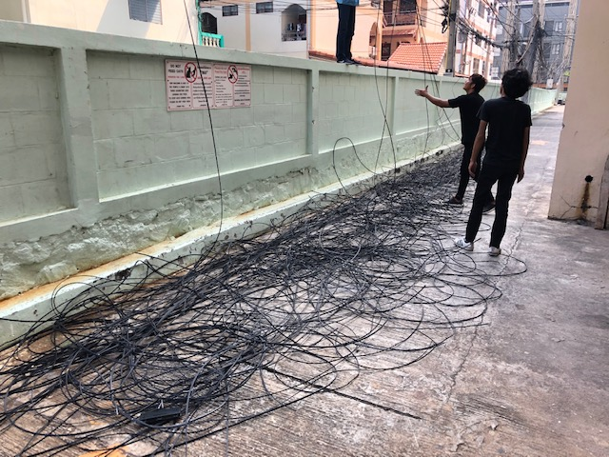

15. Staircase

Areas that had water damage are being repaired.

16. Ceiling wiring floors 4 and 5

We plan to cover exposed wiring on floors 4 and 5 as soon as technicians are free from more important work. We will employ 1 more technician.

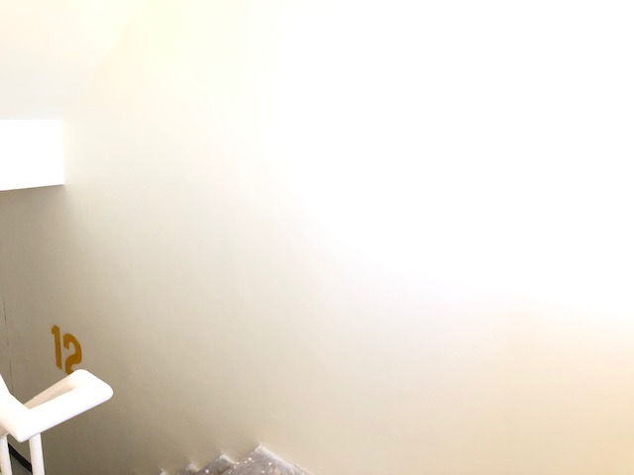 | 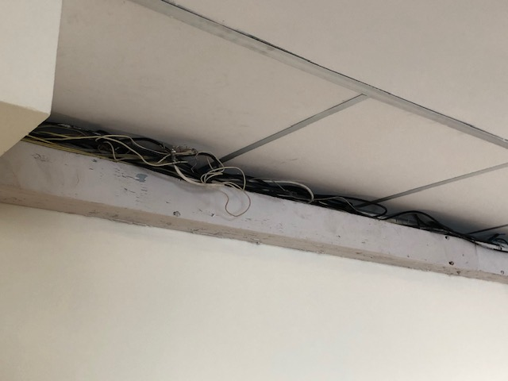

17. Cracks floor 15

Contractors will repair cracks on the roof and floor 15 caused by movement of the building.

18. Feedback and suggestions

There is a form on the new website to contact the committee directly.

http://www.centercondopattaya.com

> INFORMATION
> COMMITTEE

